FACULTY SENATE MEETING MINUTES
North Carolina A&T State University
Virtual Meeting via Zoom
Tuesday, September 22, 2020
3:00 p.m.

Dr. Julius Harp, Chair Presiding

Senate Members Present: Jeffrey Alston, Narayan Bhattarai, Stephen Bollinger, Dong Yang Deng, Zachary Denton, Nicole Dobbins, Yewande Fasina, Galen Foresman, Julius Harp, Scott Harrison, Evelyn Hoover, Sherrell House, Karen Jackson, Yahya Kamalipour, Hyung Nam Kim, James Kribs, Luba Kurkalova, Yu-Tung Kuo, Minyong Lee, Nicole McCoy, Kimberly McNeil, Ahmed Megri, Shona Morgan, William Randle, Ioannis Raptis, Dave Schall, Amy Schwartzott, Chantel Simpson, Shon Smith, Evelyn Sowells-Boone, Hong Wang, James Wood.

Departments Not Represented: Computational Science and Engineering, Computer Science, English, Social Work and Sociology, Physics, Psychology

The meeting was called to order by Chair Julius Harp at 3:05 pm.

Approval of the August Faculty Senate Minutes
It was properly moved and seconded to approve the August minutes. Senators unanimously approved the minutes.

New Programs and Curricula Committee Dr. Galen Foresman
Dr. Foresman presented curriculum changes for four departments: Agribusiness, Applied Economics, and Agriscience Education; Educator Preparation; Computational Science and Engineering; and Accounting and Finance. These packets were reviewed and approved at the New Programs and Curricula Committee meeting on September 8, 2020.
- Dr. Randle made a motion to approve the packets as presented; it was seconded by Dr. Harp. The packets were approved unanimously by senators.

Dr. Foresman will share the curriculum forms in the chat.

Academic Calendar Committee Dr. Galen Foresman
The committee will meet in the next month to look at calendars for the next several years. Some senators questioned the role of faculty in creating/approving the proposed Spring 2021 calendar and how much involvement the faculty have with general calendar development.
- Dr. Foresman said that since last year, he has been getting a copy of the calendar from the registrar for faculty review. While the registrar isn’t technically in charge of the calendar, her office has primary responsibility for it.
- Dr. Foresman shared what he has heard about the Spring 2021 calendar, which will likely feature a later start date and elimination of typical breaks. This calendar hasn’t been finalized at this time but will be in the very near future. He is unsure of the role of the Academic Calendar Committee during the pandemic and is sure that calendars can be overruled in times of pandemic.

Educational Policy Committee Dr. Zachary Denton
The senate voted to approve the Office Hours policy sent forth by the committee, but the Provost’s Office has not responded. Dr. Denton plans to reach out to her for follow up in the hopes of concluding this conversation before moving onto other committee work.
- Dr. Denton shared a copy of the policy proposal with senators:

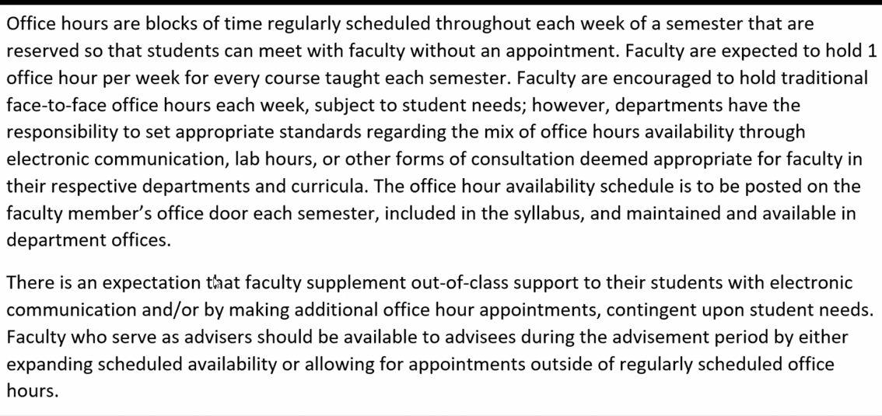
- Dr. Harp asked if the pandemic has shed light on any new information or data that can be shared with the Provost to support the proposed policy.
  - Dr. Morgan asked if holding dedicated time for an asynchronous course counted as office hours and also wondered if we could collect data from the COVID situation. Dr. Foresman suggested that there may be data showing online course interaction/advising through Blackboard Collaborate, depending on faculty use.
  - Dr. Harp believes that students could provide important information about faculty advising and access. Student leaders will be invited to next month’s senate meeting.
- Dr. Randle reiterated the fact that the current policy – of 10 hours – needs to be adjusted. He would personally prefer that the policy not include a defined number of hours, as a “one size fits all” policy will not work. He asked the committee to share any prior feedback that they had received on the proposed policy.
  - Dr. Foresman believes that the Provost is hesitant due to the proposed 1 office hour per week per each course. He thinks that she would be more supportive of alternate meeting times with students.
- There was also some discussion about the wording of the proposed policy, though it should be noted that this proposal was approved via senate vote last year.
  - Dr. Harrison suggested that we reconsider the statement that additional office hour appointments should be made, contingent upon student needs. On a similar note, Dr. Dobbins wondered if students might expect faculty to make individual/separate appointments. Dr. Denton said that he is unsure of students’ current/general understanding of office hours. He is open to future wordsmithing, however.
  - Dr. Smith asked if the policy should have wording to differentiate expectations for undergraduate vs. graduate student advising. Dr. Foresman shared that graduate faculty were considered during the policy drafting, and the suggested reduction to 1 office hour per course should better accommodate faculty who mentor graduate students.
  - Dr. Redd said that the proposed policy wording could be overwhelming to NTTF, who could be teaching 5 classes each semester. She suggested wording that would better accommodate individual faculty workload. Dr. Foresman and Dr. Denton acknowledge that workload is an important consideration and believe that the proposed policy reflects a better scenario for tenure-track and NTTF.
  - Dr. Kelly shared that a faculty office hours survey showed that students actively use only 2 office hours per week (on-site), but that faculty report spending 5-7 hours each week emailing students (often well after business hours). She wondered if the policy could be reworded to include a 2-hour minimum number of office hours.

Once the Office Hours Policy has been finalized, the committee will move to discuss the previously distributed syllabus revision in addition to a few other policies requested by the Provost for consideration.

Handbook Committee
No report.

Welfare Committee Dr. Bill Randle
The Committee will meet on the second Tuesday in October, which will continue through the academic year. The committee will address faculty workload, NTTF representation on campus, and strategies for increased faculty involvement in campus decisions.

Nominating Committee Dr. Shon Smith
Dr. Smith will soon complete his onboarding with the Faculty Senate Chair. Dr. Harp said that the first order of business will relate to representation on the Hearing and Reconsideration Committee and the Grievance Committee.

Constitution Committee Dr. Scott Harrison
An October meeting will be scheduled for this committee.

NC Voting Registration Aigne Taylor, SGA Junior Class President
Raymond Trapp, Director of External Affairs

Ms. Taylor provided an overview of campus initiatives to promote student voting. She spent particular attention explaining the voter registration process for students living on campus. There is a goal for 100% voter registration on campus, and she shared the youcanvote platform, turbovote, and voter411.org/ballot as helpful resources.

Mr. Trapp provided information about faculty initiatives. Aggies Activate the Vote, a new website, went live today. It contains links to help the entire A&T community ensure they are registered to vote, an overview the institution’s historical work on social activism, and a listing of key dates and locations/modes of early voting.

Dr. Dobbins suggested that the group create an infographic with the Aggies Activate the Vote website link for faculty to put in our course shells. Mr. Trapp said that there is going to be a big social media push and all digital information will be shared with Dr. Harp and Dr. Foresman.

Faculty Assembly Update Dr. Nicole Dobbins
Dr. Dobbins informed senators about the recent request to complete a survey about racial equity, diversity, and inclusion in the UNC system. She encouraged all senators to complete the survey and spread it to other faculty.

Dr. Dobbins also shared information from a recent BOG meeting that relates to the role of the system President in Chancellor searches. The President can now make recommendations for the Chancellor position, which could sidestep the work of an on-campus search. While the policy was approved, many campuses are issuing resolutions in response. The policy needs review and all faculty should pay close attention.

Dr. Dobbins also said there is going to be a shared governance document coming out to all administrators. Developing strong positions for shared governance is really important, particularly as we move into a period of likely and harsh budget cuts. She said that there is a clear lack of shared governance across the UNC system. A&T has a bit of stronger voice and role than it appears that others have, but faculty voice should be maintained.

Statement from the Chair Dr. Julius Harp
Dr. Harp began his remarks by reiterating the need for shared governance. He and Dr. Foresman recently had their regular meeting with the Chancellor and Provost. While they brought forth many concerns, much of the conversation centered around COVID-19. The current positivity rate is 2.5-3%, which is a relatively low rate. It appears that students are abiding by the rules. The Chancellor and Provost shared some of their efforts to offset potential budget cuts and minimize negative faculty impacts from the virus. There are initiatives to solicit additional governmental funds to support HBCU’s and our healthy enrollment numbers are also a benefit during this time.

Overall, Dr. Harp believes that administration is willing to negotiate with the faculty, are responsive to concerns, and are interested in faculty involvement. He requested senator input and questions:
- Faculty still had questions about whether or not weekly testing is being done for students.
  - Dr. Harp said that he believes that on-campus students in the dorm are required for testing, but he will clarify. Dr. Dobbins said that the extent of mandatory testing is a fever check. This calls the university reporting into further question.
  - Dr. Harp is also unsure if students who are tested off campus are included in the on-campus numbers, but he will ask.
- Faculty were also curious to know if someone from faculty, staff or administration tests positive, is the number counted with on-campus numbers?
  - Dr. Harp is unsure.
- Dr. Redd asked if the testing is for an active infection or is it an antibody test?
  - Dr. Foresman said they can look into this question.
- There were several questions about whether testing is free for faculty and staff.
  - Yes, though you do have to have ID and your insurance card. The website also instructs individuals to contact the health center before going in for a test.
- There was also general concern about follow-up being done in cases in which students test positive. If they are in a face-to-face class, should the faculty and class quarantine? If students tell faculty that they have tested positive, does this mean that they have necessarily reported the positive to campus?
  - Dr. Randle said we need to have clear website information with protocol information – to identify what we should do if we or students test positive. Dr. Randle also suggested that there is a need for more often and brief updates from the Chancellor
  - Dr. Drye shared: https://www.ncat.edu/coronavirus/aggies-care/protcols-for-students.php. It appears that students have been encouraged to go to the student health center for testing. Faculty are not technically supposed to ask for details about their testing and cannot tell a student they must be tested. Notes from the student health center should designate a return date but are confidential otherwise and provide no further details. However, she is unsure what to do if a student is tested away from the health center. She has also had issues where students have been exposed to others with COVID but didn’t want to be tested.
- Dr. Randle would like student and faculty feedback on the 2.5-hour time blocks being used for courses this semester and proposed for Spring 2021.
- Dr. Morgan asked if there was an update on calendar changes for RPT/PTR for the upcoming year?
  - Dr. Foresman said that will be discussed in an upcoming meeting with the Provost (this week or next).
- On a related note, Dr. Kuo asked about the 1-year extension of RPT/PTR. According to review policies, faculty must present 5 years of information – if they take a 1-year extension, should they now provide evidence of 6 years or just the most recent 5 years?
  - Dr. Foresman said his assumption would be that faculty would report all 6 years. However, this needs follow-up with administration to ensure a written institutional standard.
- Dr. Redd asked if there was any updated information about the NTTF evaluations and promotions from the 2019-2020 cycle.
  - Dr. Foresman said there are no new updates; Dr. Smith Jackson is done with her phase and the next step is Chancellor and Provost signatures.

Dr. Foresman believes that a lot of the faculty concerns brought up can be addressed through a separate meeting with the Provost. Dr. Harp ended his statements encouraging senators to share their concerns. He also encouraged senators to recommend speakers for upcoming meetings.

The meeting adjourned at 5:40PM

Dr. Elizabeth Newcomb Hopfer
Secretary

