FACULTY SENATE MEETING MINUTES
North Carolina A&T State University
Virtual Meeting via Zoom
Tuesday, October 27, 2020
3:00 p.m.

Dr. Julius Harp, Chair Presiding

Senate Members Present: Jeffrey Alston, Uchenna Anele, Mohd Anwar, Narayan Bhattarai, Stephen Bollinger, Dong Yang Deng, Zachary Denton, Nicole Dobbins, Galen Foresman, Julius Harp, Scott Harrison, Evelyn Hoover, Sherrell House, Karen Jackson, Yahya Kamalipour, Hyung Nam Kim, James Kribs, Yu-Tung Kuo, Luba Kurkalova, Minyong Lee, Nicole McCoy, Kimberly McNeil, Ahmed Megri, Shona Morgan, William Randle, Ioannis Raptis, Kristen Rhinehardt, Dave Schall, Amy Schwartzott, Kalynda Smith, Shon Smith, Evelyn Sowells-Boone, Hong Wang, James Wood, Osei Yeboah.

Departments Not Represented: English, Physics, Social Work and Sociology

The meeting was called to order by Chair Julius Harp at 3:05 pm.

Approval of the September Faculty Senate Minutes
It was properly moved and seconded to approve the September minutes. Senators unanimously approved the minutes.

New Programs and Curricula Committee Dr. Galen Foresman
Dr. Foresman presented curriculum changes for three departments: History, Liberal Studies, and Animal Sciences. These packets were reviewed and approved at the New Programs and Curricula Committee meeting on October 13, 2020.
- Dr. Wood asked if the HIST 130 is part of a bigger group of revisions coming from the History department? Dr. Foresman shared that more substantial revisions are forthcoming in November.

Dr. Randle made a motion to approve the packets as presented; it was seconded by Dr. Harp. The packets were approved unanimously by senators.

Academic Calendar Committee Dr. Galen Foresman
The committee has not yet met. Current calendars are in flux due to COVID. Next year’s calendar has already been approved, but the committee will be pulled together soon to review calendars several years out.

Dr. Randle moved to delay the Nominating committee report and it was seconded.

Educational Policy Committee Dr. Zachary Denton
The Provost’s Office has returned feedback to the committee regarding the proposed Office Hours Policy. Dr. McEwen’s response suggested a designated number of hours per week. The committee sent back the following response:
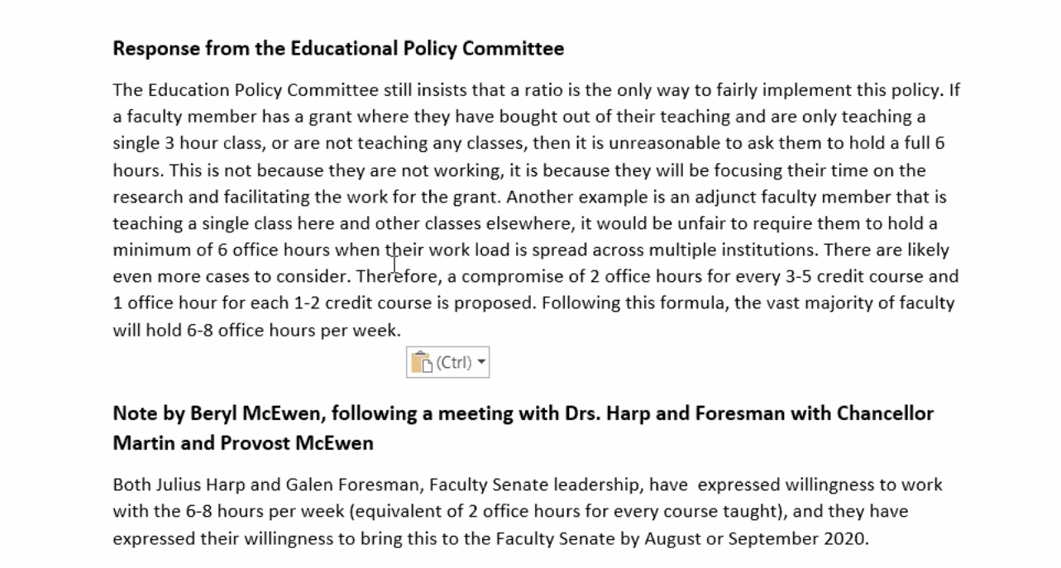
Dr. Denton shared his thoughts that this iteration, while maybe not ideal, is the best possible compromise and does offer flexibility. Dr. Harp said that the autonomy given to the department chair and the flexibility in mode is a big improvement over previous policies.

Senators provided the following comments:
- Dr. Harrison said that this is a positive step and we can always revisit the debate in the future. He then shared that there are research courses that are 6 credit hours. How would the proposed policy work for these courses?
  - Dr. Denton said the proposed policy intent was 2 office hours for every 3+ credit hour course. There was an exception provided for the 1-2 credit hour courses. Office hours also could vary depending on how departments calculate load – number of courses or number of credit hours?
- Dr. Randle said that he thought it would be helpful to come up with some common language so that we can express the policy and what it means uniformly to the students.
  - Dr. Hoover said she believes this is clear.
- Dr. Jackson asked if the virtual office hours could include time spent answering email, or is it time spent waiting in a zoom room?
  - Though there was some concern about “waiting in a zoom room,” it is the same issue with face-to-face. Faculty often hold office hours with no student attendance. Many students avoid the pre-set office hours, in favor of requesting separate appointments; our availability is much different now. There will be no policy that fits all of these needs and the language may never fit precisely for every situation.

It was moved and seconded to approve the committee’s response / suggestion to Provost McEwen (see above). The motion passed with 28 voting in favor, 2 opposed, 2 abstaining.

Q&A with the Provost Dr. Beryl McEwen
Dr. McEwen was invited to this meeting to engage in a discussion with senators. Topics:

COVID-19
Dr. Kurkalova shared serious concerns about reporting/under-reporting of COVID cases. Of specific note:
- Reporting of positive cases: Faculty cannot report cases if students do not.
- Contact tracing: Faculty are not being told about known, reported cases of COVID. Dr. Kurkalova said that a student living in a dorm was diagnosed and the student was in a faculty member’s face to face class, but faculty were never told. Dr. Megri also shared that he had 2 students in one of his labs who tested positive yet he was never contacted by the university.
  - Dr. McEwen’s reply: If someone is found to test positive, there is staff in health services who do the contact tracing – reaching out to people who came in contact with the student or faculty to recommend quarantining and testing.
- Uneven timing of dashboard updates: Data are difficult to interpret because of unequal intervals of reporting. See the alternative calculation by a faculty member below:
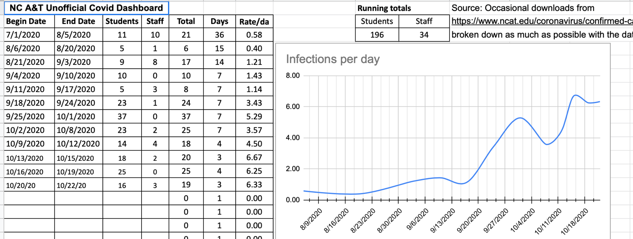
Is it possible to change the way the data are reported for more transparency?
  - Dr. McEwen’s reply: The original goal was to update the dashboard every 5 days, but she can put in a request for more frequent reporting. There is a team on campus led by interim director of health services and includes the Vice Chancellor of the Division of Research, the Dean of the School of Nursing, and emergency management personnel. While there isn’t a standing committee meeting for this group, they convene as needed; the last meeting was at the time of the spike in Pride Hall. The Provost speaks with the deans once every other week, and she is aware of the faculty concerns. The Provost has conveyed faculty concerns to the committee and Dr. Webb has offered to speak to deans. The committee has assured the Provost that locations of known positives undergo deep cleaning. All classrooms are deep cleaned nightly and therefore do not require additional cleaning. She suggested that the faculty may like to hear from Dr. Webb and/or the Director of Physical Plant.

Faculty Evaluation
Dr. Raptis asked if faculty going up for tenure and promotion or evaluation would be required to report teaching evaluation results during the pandemic? Students may have directed stress and frustration over online learning and the pandemic toward faculty, creating biased results.
- Dr. McEwen’s reply: There are consistent concerns voiced about biased student evaluations, even in pre-pandemic times. She is unsure that there is any realistic way to remove bias through the evaluations. While the student evaluation data is collected and she believes it is helpful feedback, she does not believe it has ever been mandatory to report them in dossiers. If faculty choose to report evaluation data, she believes that RPT and PTR committees will look at overall trends and will cautiously observe any data from the pandemic.
- Dr. Morgan asked for clarification on the information that was shared in Spring 2020 – in which faculty were told that we could decide whether to use student evaluations or not. She is concerned that once data is collected there is some group or situation where it will be used. She reiterated that faculty evaluations are often the location where students can register their frustration and upset. Dr. Morgan shared that she had heard of several other institutions that had decided to forego collection of evaluations.
  - Dr. McEwen’s reply: Faculty have the option to not include evaluations in the dossier. She encouraged faculty to make their own decisions about what to present, and if evaluations from the pandemic are included (and a concern), faculty can include a narrative. Deans and the Provost office will remind RPT committees to extend professional courtesy of their evaluations during the pandemic.
Dr. McEwen said that she isn’t aware of any UNC system institution that has decided not to collect faculty evaluations. It is A&T’s institutional (internal) requirement to collect these evaluations.
Dr. Morgan suggested that we propose a statement that evaluations are formative, not just summative, and should be used to guide teaching. Dr. Randle has made a note of this for the Faculty Welfare Committee to pursue.

On a related note, Dr. Dobbins said that there are systems of barriers and inconsistencies in promotion and tenure. There is a need for training at all levels on how to fairly evaluate faculty.
- Dr. Harrison believes that this is an essential point. Part of the issue is that departmental and college administrators need to ensure clarity and updates regarding promotion and tenure criteria, with direct involvement of faculty within their academic units.
- Dr. McEwen reminded us of the ADVANCE IT group, which is now holding training about implicit bias.

Dr. Malloy asked if the NTTF review process for Spring 2020 had been completed, as she has not yet received her letter.
- Dr. McEwen’s reply: She will follow up; all letters should have been sent.
- Dr. Redd shared that she had received a letter and wondered if there was any administrative effort toward letting NTTF know they are appreciated. The letter felt cold and didn’t convey appreciation to NTTF or incentivize effort.
  - Dr. McEwen’s reply: She acknowledged that she had heard some NTTF frustration about the lack of raises when promoted. She said that NTTF are highly valued on A&T’s campus, and would like to explore ways to show this appreciation; specifically, what would NTTF appreciate? The Provost also said that she has encouraged dean’s to offer more of the NTTF positions as TT, though she is aware that some faculty do not wish to be TT.
    - Dr. Randle said the Faculty Welfare committee will soon submit a resolution to the Provost that will address promotion and advancement concerns for NTTF.

Dr. Kurkalova asked if there were plans to extend/postpone RPT and PTR for any faculty working through the pandemic?
- Dr. McEwen’s reply: The option was extended for faculty up for review in the 2020-2021 academic year. If there is faculty interest for other extensions she encouraged the senate to use its channels make this statement. Dr. Randle said the Faculty Welfare committee will follow up.

Course Delivery
There was also discussion about the multiple teaching options available for the Spring semester. In addition to fully asynchronous online classes and face-to-face classes, there is an option for remote teaching at a given time. All asynchronous online courses are asked to hold at least 1 hour of engagement per week. Dr. Dobbins asked if she can lecture during the 1-hour engagement each week for asynchronous classes?
- Dr. McEwen’s reply: Ideally, sessions should be designed around engagement rather than lectures. Sessions should be recorded if they are used as lectures.

Dr. Randle and Dr. Rhinehardt asked if the Provost has been given any feedback about the 2.5 hour time blocks?
- Dr. McEwen’s reply: She has been told that faculty and students don’t like it. She said that we have to do it to observe social distancing. This is just a pandemic response, not a new standard for the university.
- Dr. Cobb said that faculty will have to invoke different pedagogy and andragogy and change the way we teach. The CTE and DLFF have been established at the university to help with this. To teach effectively during the 2.5 hours, faculty will have to engage students and provide opportunities for true interactions in learning. If faculty try to use the lecture format during this 2.5 hours it will be brutal.
  - Dr. Kurkalova agreed, but said the extra work of changing pedagogy is another argument for allowing all faculty to postpone their RPT and PTR applications, if faculty so choose. Senators agreed; this is a very heavy lift for faculty even with online teaching experience.
- Dr. Harp said that student leaders will attend the November meeting and we can get the student perspective at that time.

Nominating Committee Dr. Shon Smith
Dr. Smith started his report with a request to discuss the 2020-2021 nominations for the Hearing and Reconsideration and Grievance Committees.
- Dr. Newcomb shared information on Dr. Harrison’s behalf. Dr. Harrison had, at the Senate Executive Committee’s request, asked each of the 2020-2021 nominees whether they were voted on by their respective colleges, or if they had been selected by their deans. In all but 4 cases, nominees were selected by deans.
- Dr. Harp said that he believed some colleges may have selected, rather than voted in, their nominees due to the pandemic. There are very critical cases awaiting these committees and they need to be functional sooner rather than later. He wondered if the senate felt comfortable moving forward with the committees as nominated, since some of the proposed candidates have served before. He also suggested that the previous Grievance Committee could be reactivated to address cases waiting now.
- Dr. Cobb said that the Constitution states that these nominees cannot be administratively selected, and that they should be selected by a college vote. He cautioned that if the committees aren’t formed through proper procedures, it could open the institution up to litigation, depending on the severity of the case.
  - Dr. Randle agreed that the senate needed to confirm that there has been a legitimate vote before moving forward.
  - There was a general consensus that deans who selected, rather than elected, their nominees should be asked to hold a college vote. This should be sent as an urgent request, with the Provost and Legal copied.
  - Dr. Dobbins asked if the senate could then do an electronic vote to resolve the issue?
    - Dr. Cobb said that we should refer to the Constitution to determine if we need a majority of senators voting (rather than a quorum) for this to be a valid approach. He also suggested that we collect the vote electronically in an anonymous poll, rather than an email vote.
Dr. Smith will work with the committee to send out the election requests to deans. He would like to request that we do an email vote by the senate to get this situation resolved quickly.

Dr. Harp said that we also need to increase the membership on the Nominating committee, and we need to ensure even representation from the various colleges. Dr. Randle said that he believes volunteers are difficult to come by because the service isn’t recognized in a meaningful way.

Handbook Committee Dr. Evelyn Hoover
No report.

Welfare Committee Dr. Bill Randle
The Committee met in October and talked about two main issues:
- NTTF concerns
  - The committee has researched NTTF organization at other institutions. The Colorado University System has NTTF responsibilities, compensation, and representation and voice very clearly outlined. The committee would like to use this as a model for NTTF roles on our campus.
  - Dr. Randle acknowledged the tone of the promotion letter being used at A&T is very cold and offers no permanent compensation with rank advancement.
  - He has shared a proposed resolution with the Executive Committee and will bring it to the full body at a future meeting.
- Mental and physical faculty health
  - The committee discussed several practices that contribute to poor faculty health, such as requiring faculty to work without pay (esp. during summer), administrative emails well outside of normal business hours, and the low involvement of faculty in decision-making.
  - Dr. Randle requested that senators send him information about the issues affecting the welfare of faculty in their areas. He will then prioritize and work with the committee to create resolutions.
    - Dr. Morgan would like the committee to address RPT/PTR extensions for all faculty, not those just going up for review in 2020/2021.
    - Dr. Kurkalova said that there may need to be more discussion about measures to protect faculty safety in the pandemic: contact tracing, thresholds for positivity rates that would warrant online teaching, and what to do in the case(s) of students testing positive in our face-to-face classes.

Constitution Committee Dr. Scott Harrison
No report

The meeting adjourned at 5:30PM

Dr. Elizabeth Newcomb Hopfer
Secretary

