FACULTY SENATE MEETING MINUTES
North Carolina A&T State University
Virtual Meeting via Zoom
Tuesday, August 25, 2020
3:00 p.m.

Dr. Julius Harp, Chair Presiding

Senate Members Present: Soonok An, Narayan Bhattarai, Stephen Bollinger, Zachary Denton, Nicole Dobbins, Yewande Fasina, Galen Foresman, Bala Gokarju, Julius Harp, Scott Harrison, Evelyn Hoover, Sherrell House, Shanthi Iyer, Karen Jackson, Yahya Kamalipour, Hyung Nam Kim, James Kribs, Luba Kurkalova, Yu-Tung Kuo, Minyong Lee, Nicole McCoy, Kimberly McNeil, Ahmed Megri, Shona Morgan, William Randle, Ioannis Raptis, Dave Schall, Amy Schwartzott, Chantel Simpson, Shon Smith, Evelyn Sowells-Boone, Hong Wang, James Wood.

Departments Not Represented: Built Environment; Computer Science; English; Physics; Psychology

The meeting was called to order by Chair Julius Harp at 3:00 pm.

Approval of the April Faculty Senate Minutes
- It was properly seconded to approve the April minutes. Senators unanimously approved the minutes.

Statement from the Chair Dr. Julius Harp
Dr. Harp began his comments with a welcome to the new academic year. New senators were asked to introduce themselves.

All senators are expected to sign up for a standing committee. Dr. Harp has shared an electronic sign-up via email, in which senators can indicate preference for committee service.

Dr. Harp then provided some information about Fall 2020 COVID-19 preparation
- The UNC System has pushed face-to-face instruction, in part to ensure financial balance. NC A&T has opened with approximately 50% online/50% face-to-face instruction.
- Dr. Harp and Dr. Foresman were involved in the planning process over the summer and have also been added to the budget committee that will begin meeting at the end of August. Dr. Harp has asked faculty to express their concerns freely to ensure shared governance. Dr. Dobbins is serving on the Executive Committee of the Faculty Assembly and will be a strong voice for the faculty this upcoming year. Dr. Harp will continue to contribute through the Chairs meetings.

He also briefly mentioned some other Senate items for 2020-2021
- The Faculty Welfare committee will work toward a faculty salary study and NTTF representation.
- The Education Policy committee will resolve the office hours policy that has been a focus over the past year.
- There is also concern about the work that 9-month faculty are asked to do over the summer without being paid.

Dr. Harp ended his portion of the meeting by asking if senators had any comments based on the information he shared.
- Senator Randle asked that Dr. Foresman and Dr. Harp stress the importance of protecting the academics/teaching arm of the university in budget discussions.
- Senator Dobbins shared some UNC System concerns about the COVID-19 CARES funds – specifically, how much was set aside for faculty? She encouraged all faculty to quickly complete any surveys that come out to assess faculty technology needs. Surveys will be distributed to senators through Dr. Harp.
- Senator Bollinger said that the COVID dashboard doesn’t appear to be working. Even when it was working, it was not detailed nor updated regularly.
  - Apparently, the site has moved: https://www.ncat.edu/coronavirus/aggies-care/confirmed-cases.php
  - Senator Dobbins asked if all students returning to dorms were tested, how often, and how certain can we be that the dashboard presentation is valid?
    - There was significant confusion and mixed messaging regarding testing procedures. Senator Bollinger also said that the university cannot only focus on testing of students living on campus. Many students who do not live on campus are regularly coming to campus and are at the Student Center, the library and in classrooms.

Statement from the Vice-Chair Dr. Galen Foresman
Dr. Foresman started his statement with a welcome.

His comments centered on ways that faculty voice can be best heard for shared governance.
- He encouraged faculty to be vocal when/if put in situations that unnecessarily increase workload and/or ignore faculty needs. During the summer, he frequently observed administration and non-faculty using the word “professional” in situations in which some proposal might be negatively viewed by faculty (i.e. “the faculty are professionals and would surely not take issue with a change to the syllabus template several days before the semester”). Dr. Foresman said that any faculty member who hears statements like this, which are dismissive of legitimate needs and concerns, should argue against them.
  - In the chat area, several senators questioned whether the syllabus revision should have been approved through the senate?
- Dr. Foresman wants to have more open, frank discussions about things that are happening in our colleges.
  - He shared recent comments from his dean that indicated that the college leaders were department chairs. Dr. Foresman believes that faculty are the real leaders and need to be included and considered in administrative discussions.
  - Dr. Foresman wants the senate to be a safe space for faculty to air their concerns.
- He also discussed how standing committee service gives faculty a voice in important decisions. While the Nominating committee often lacks members, the function of this committee (to recommend faculty for university-level service responsibilities) is a very important one. Fully functioning standing committees is one way to ensure that faculty have a say in important institutional processes.
- Dr. Foresman reminded senators that the university regularly issues draft policies for review and input. Senators should review these policies and encourage their colleagues to do so as well.
  - Several policies recently came out for review (student grievance, policy on policies, faculty credentialing)
    - Dr. Harp and Dr. Foresman were able to provide feedback on the policy on policies. They requested more time for review and pointed out that the first draft of the policy completely excluded faculty participation.
  - Senator Randle said that policies should not be issued for review over the summer, when faculty are not technically employed and may not be checking email as regularly.
- Several senators supported this push for shared governance.
  - Senator Dobbins said that the Faculty Assembly wants more faculty voice across the entire system. They are meeting weekly. If there are faculty issues, there are avenues to having them heard.
  - Senator Randle encouraged all senators to regularly talk with their departmental colleagues – and to bring concerns and issues before the senate.

HR Presentation Erickia Elbert and Kristin Leak
Ms. Elbert started with a welcome and some brief information related to some of the topics previously discussed in the meeting.
- She shared that the COVID-19 dashboard website will be updated weekly.
- She also provided a listing of locations where faculty can be tested for COVID-19
  - Alamance County: Grand Oaks Center at Alamance Regional, 1238 Huffman Mill Road, Burlington, NC
  - Guilford County: Green Valley Campus, 801 Green Valley Road, Greensboro, NC (entrance off Lendew Street)
  - Rockingham County: 617 S. Main Street, Reidsville, NC (across from Annie Penn Emergency Department) Testing locations
- She also said that student testing has varied by group. When athletes returned, all were tested for COVID-19. At move-in, students living on campus were temperature-tested. Every Saturday students are encouraged to be tested if they live in the dorms. The university has also partnered with Thermo Fisher Scientific to offer more structured on-campus testing beginning at the end of August.

Ms. Elbert then shared a “Returning to Work” presentation that covered several key topics:
- Self-monitoring
  - Any faculty member coming to campus should fill out the daily self-monitoring form in advance. If we answer yes to any of the questions, faculty should not report to work and should contact the health center. The health center is an important part of the institutional process; they will ultimately provide a note to allow the faculty member to return to work.
- Safety training
  - 95% of faculty and staff have already attended one of the Tuesday/Thursday safety training sessions delivered via zoom. This is the last week of the zoom delivery; the training will then move to CLOE.
- Masks
  - Must be worn at all times throughout campus
  - She encouraged faculty to be mask police if necessary.
  - Some departments have face shields for faculty use. Masks should be worn with the face shields.
  - Part-time faculty will be able to pick up their A&T face mask sometime in the near future. She is not sure if full-time faculty will have another opportunity to pick up their mask, but will follow up.
- Mental and emotional wellbeing
  - There are multiple avenues for faculty and their family members to receive mental and emotional support. EAP ComPsych use has increased. NC A&T Counseling can be used by faculty as well.
- Reporting concerns
  - If faculty are concerned about anything (observations, student behavior, practices), they can send an email to PRTW@ncat.edu. This is a dedicated email for COVID-19 concerns.
  - Faculty with concerns about their building, office, or classroom spaces should communicate these concerns to their building reps, who will forward them to facilities
- Faculty and Staff Senate Social Justice Series
  - This 2-part series is focusing on important social justice topics relevant to the A&T community. The first, “Aggies Embrace” focused on the history of A&T in the area of social justice. The second, “Aggies Mobilize” will focus on voting. Part 1 was held on August 11; Part 2 will happen in September.
- Ms. Kristin Leak shared information about faculty work provisions, which cover faculty in the event that they cannot work or telework.
  - There is now a separate page on the HR website related to FFCRA. Important graphics shared during the presentation addressed how faculty should proceed in the event they cannot work or telework due to:
    - Quarantine/Isolation order/COVID-19 diagnosis
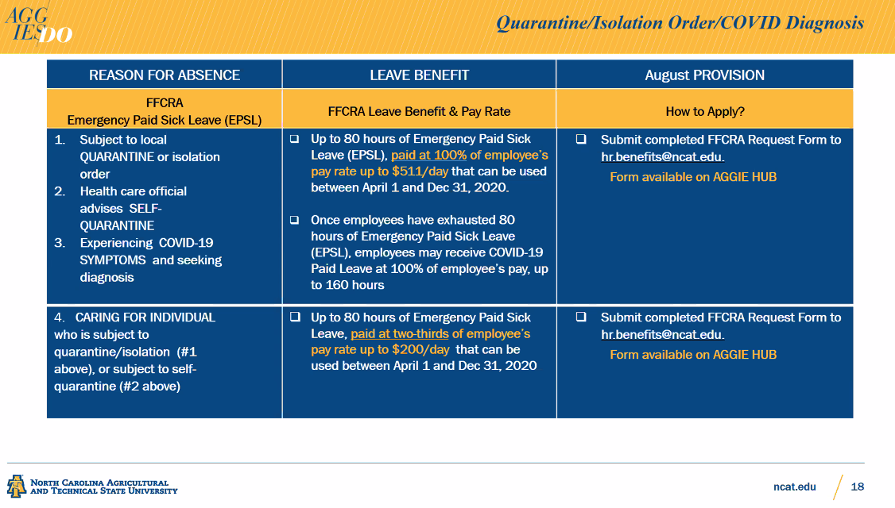

    - Childcare facility closed

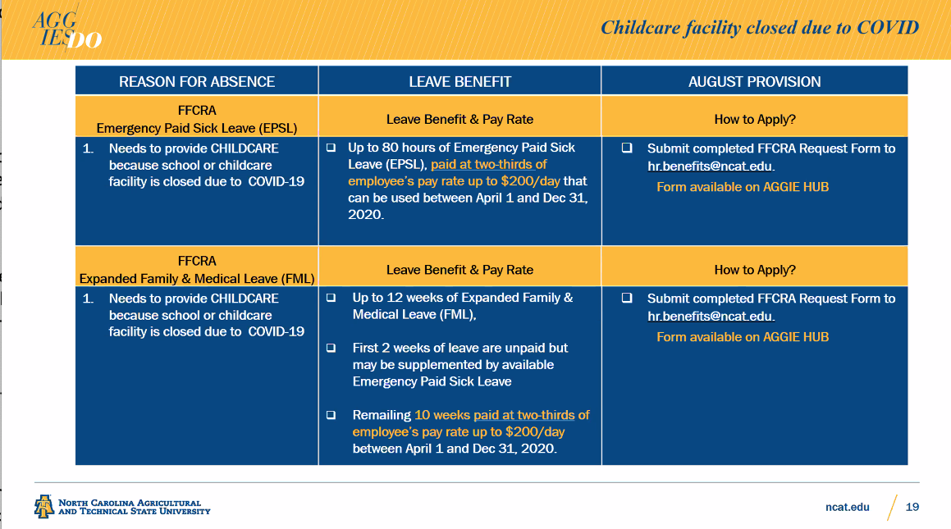

  - If faculty have questions, they can reach out to Ms. Leak or send them to PRTW@ncat.edu.
- Q&A with the senate:
  - What is being done to monitor student behavior?
    - Ms. Elbert said that student leaders have shared of peer to peer communication to encourage good behavior.
    - Students behaving counter to recommendations are putting themselves at risk of campus removal.
    - She said that faculty who have concerns about student behavior should contact the Dean of Students, Marc Williams (marcwill@ncat.edu)
  - How often are students tested?
    - Testing is offered every Saturday.
  - Will the university provide more granular data about the virus spread on campus, such as that shared by NCSU and UNC-Chapel Hill? Faculty would like to see where infections are occurring on campus, how many tests have been done, the percentage of overall students being tested, and when the students were tested. A recent article criticized NC A&T’s data reporting as the largest HBCU.
    - Ms. Elbert said that the presentation of data may change as the situation changes. Right now, the campus does not have any clusters.
    - Dr. Foresman shared links to COVID dashboards in the UNC system:
      - https://update.uncg.edu/covid-19-case-dashboard/
      - https://www.wssu.edu/about/road-map-to-fall-2020/covid-19-case-dashboard.html
      - https://www.uncfsu.edu/confirmed-covid-19-cases
      - https://www.appstate.edu/go/coronavirus/
      - https://coronavirus.unca.edu/confirmed-cases-covid-19/
      - https://www.ecsu.edu/coronavirus/covidreporting.html
      - https://returnofpiratenation.ecu.edu/public-covid-dashboard/
      - https://www.wcu.edu/coronavirus/reporting.aspx
      - https://carolinatogether.unc.edu/dashboard/
      - https://www.nccu.edu/coronavirus/confirmed-cases-covid-19-nccu
      - https://www.ncat.edu/coronavirus/confirmed-cases.php
      - https://www.ncsu.edu/coronavirus/testing-and-tracking/
      - https://uncw.edu/bestnest/datadashboard.html
      - https://www.ecsu.edu/coronavirus/covidreporting.html
      - https://www.uncsa.edu/coronavirus/dashboard.aspx
      - https://coronavirus.unca.edu/confirmed-cases-covid-19/
  - Is there a ceiling/threshold for the number of positive cases before the university might transition online?
    - Ms. Elbert is not sure; she encouraged the Executive Committee to invite individuals in charge of testing to a future meeting.
  - Is there a plan to include a topic on diversity and inclusion in the Social Justice Series?
    - Ms. Elbert sent out a survey this morning to ask about faculty interests, and this topic was included as a choice. She encourages all faculty to respond to the survey.

Other Faculty Concerns
RPT / PTR calendar extensions
- Senator Kurkalova shared comments from the Economics Department. A memo from the Provost’s Office (dated July 9, 2020) indicated that faculty up for RPT or PTR review in the 2020-2021 academic year could have a one-year extension.
  - All faculty productivity has been impacted by the pandemic, not just those under review in 2020-2021. The Economics faculty suggests that the RPT and PTR clock of all faculty employed by NC A&T in February 2020 be extended by one year.
  - In addition, there are questions about whether or not (or how) the PTR extension will impact future review cycles. The UNC System requires PTR at least every five years. Will the one-year extension create a perpetual shift of everyone’s PTR clock, or is it simply an extension of this cycle and a shortening of the next?
  - Both of these concerns need to be addressed in writing.
- Senator Morgan said that Management faculty had similar concerns and wanted them to be presented to the senate. Work and home life has been significantly impacted by COVID-19 (higher course loads, larger classes, sickness, care of older family members, education of children, etc.). The faculty would like to see the same grace given to the students (which was needed) extended to us.
- In the chat, Senator Schall stated that he would personally prefer we look at adjusting standards vs adjusting the clock. Faculty are still working to whatever degree is possible. Wouldn't it be nice to receive some sort of credit for that work? We don't have a clear indication of how long this new norm will last and just pushing it down the road might not be in our best interest.

Pass/Fail option for Fall 2020
- Senator Morgan said that faculty in her department would like to know – soon – whether students would be offered the Pass/Fail grading option in Fall.
  - Pass/Fail was offered to students in Summer 2020, even though it was originally not supposed to be an option. Unfortunately, the change was never formally communicated to faculty or administrators. Students were aware of the option before faculty.
  - Senator Morgan said that she has heard that there is hesitation to publicize a Pass/Fail option early in the semester as it might affect student commitment. However, faculty need to know if and when the option becomes available.
- Dr. Foresman will take this question to the Implementation Committee. He said that the Summer Pass/Fail option did not go through the committee and voiced concern that students are consistently finding things out before faculty. Advisors in particular need this information to better advise students.

Microsoft Teams
- Senator Morgan shared that she recently found out that Microsoft Teams is not supported by the Aggie Help Desk. Given that we are in the middle of a pandemic, the university should support as many web-conferencing platforms as possible.

Fall 2020 Online Course Delivery
- The Implementation Committee, on which Dr. Foresman serves, has been asked to come up with a plan for a possible move to fully online course instruction in Fall 2020. He has already stated the need for timely communication. He wants to know if there are any immediate thoughts; other concerns can be sent to him via email. Faculty shared the following:
  - Senator Dobbins suggested that faculty be surveyed about technology needs – devices, Wi-Fi connections, printers, modems, and paper.
  - Multiple senators expressed concern about the 2.5 hour time blocks for courses.
    - Senator McNeil said that attention spans are not going to last that long and the timeframe will need to be reviewed if we move fully online.
    - Some classes actually lost time in the move to block scheduling (i.e. art and studio courses).
    - Faculty workload has increased as we are now asked to accommodate both face to face and online courses.
      - Faculty Welfare needs to revisit this issue – for NTTF and tenured/tenure-track faculty.
  - Senator McNeil said that Pass/Fail grading should be an option if we move online.
  - There is also interest in knowing the threshold for a move online. If faculty know the number or percentage of positive cases that would trigger a move online, we can plan better.
- Senators Dobbins and Redd encouraged all faculty to make use of the UNC System information offered about online course delivery (https://myapps.northcarolina.edu/digitallearning/unc-course-assets/). Some NC A&T faculty were involved in the creation of this material and it is quite good.
- Dr. Foresman asked if senators had ever been asked about identifying an online synchronous delivery option for their courses. His college was told that classes in the catalog without a specified time would automatically be asynchronous.
  - Senator Morgan said that she had been told that department chairs were given the option of offering their faculty the chance to identify a time for online synchronous course delivery. Some chairs did not communicate this as an option to faculty.
  - Senator Dobbins said that she has heard that faculty can create a synchronous meeting time for online classes, but we cannot tie grades to it.

The meeting adjourned at 5:00PM

Dr. Elizabeth Newcomb Hopfer
Secretary

