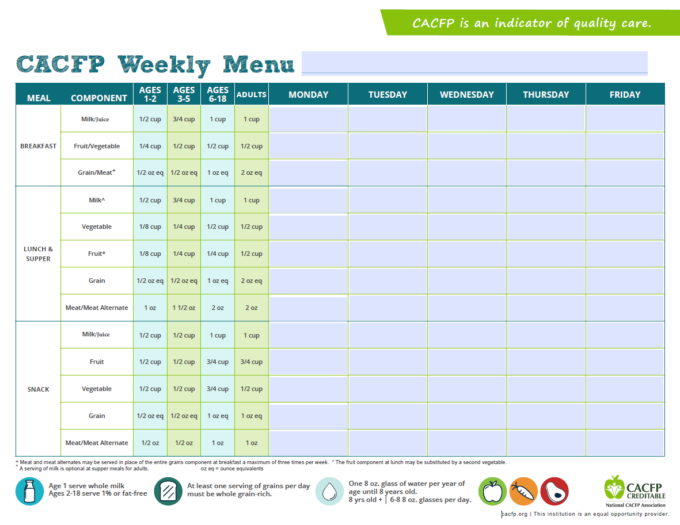
Menus are subject to change
[Grab your reader’s attention with a great quote from the document or use this space to emphasize a key point. To place this text box anywhere on the page, just drag it.]
[Grab your reader’s attention with a great quote from the document or use this space to emphasize a key point. To place this text box anywhere on the page, just drag it.]
Afternoon Snack

Lunch
Morning Snack
[Grab your reader’s attention with a great quote from the document or use this space to emphasize a key point. To place this text box anywhere on the page, just drag it.]
[Grab your reader’s attention with a great quote from the document or use this space to emphasize a key point. To place this text box anywhere on the page, just drag it.]
[Grab your reader’s attention with a great quote from the document or use this space to emphasize a key point. To place this text box anywhere on the page, just drag it.]
[Grab your reader’s attention with a great quote from the document or use this space to emphasize a key point. To place this text box anywhere on the page, just drag it.]
[Grab your reader’s attention with a great quote from the document or use this space to emphasize a key point. To place this text box anywhere on the page, just drag it.]
[Grab your reader’s attention with a great quote from the document or use this space to emphasize a key point. To place this text box anywhere on the page, just drag it.]
[Grab your reader’s attention with a great quote from the document or use this space to emphasize a key point. To place this text box anywhere on the page, just drag it.]
[Grab your reader’s attention with a great quote from the document or use this space to emphasize a key point. To place this text box anywhere on the page, just drag it.]
North Carolina A&T State University Child Development Laboratory
Sample Menu (Lunch Caterer: Taste of the Triad)
------------------

Chex Mix
------------------

------------------

Grape Juice
Beef Burrito Bowl
Mexican Rice
Orange
Pinto Beans
Milk

Froot Loops
------------------

Milk
------------------

------------------

------------------

Belvita Cookies
Milk
Turkey Sub
WG Hoagie
Peaches
Carrots
Apple Juice

------------------
Milk
Cheese Danish
------------------

Ritz Crackers
------------------

------------------

Apple Juice
Chicken Teriyaki
WG Roll
Apple
Stir Fry Veggies/Rice
Milk

Apple Jacks
------------------

Milk

------------------

------------------

------------------

------------------

Tropical Fruit
Milk
Baked Potato Soup
WG Crackers
Banana
Green Beans
Milk

French Toast
------------------

Orange Juice
Nacho Chips
------------------

------------------

Grape Juice

Chicken Nuggets
Trix
WG Roll
Pineapples
Broccoli & Cheese
------------------

Milk
Milk

